* **Actual dataframe with training dataset:**

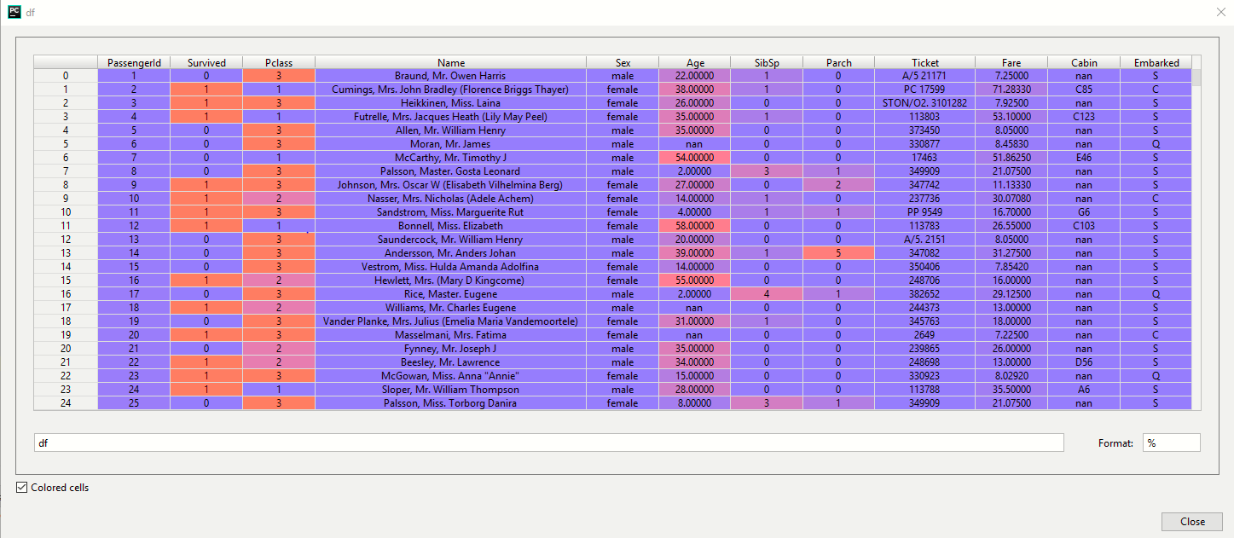

* 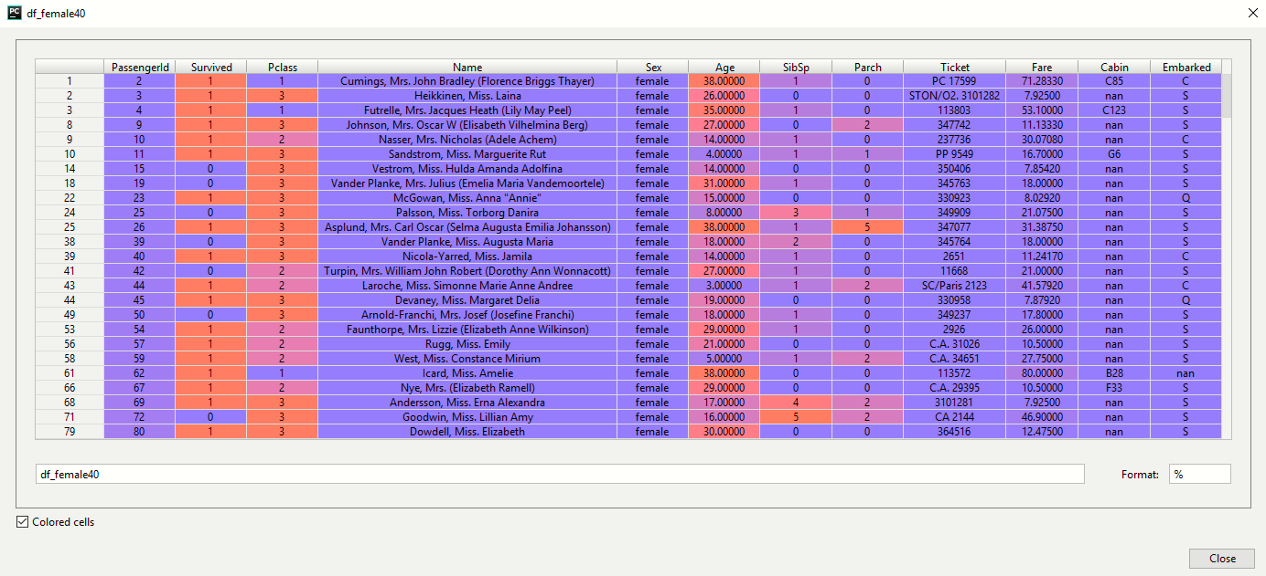**Dataframe holding data for females with age below 40:**
* 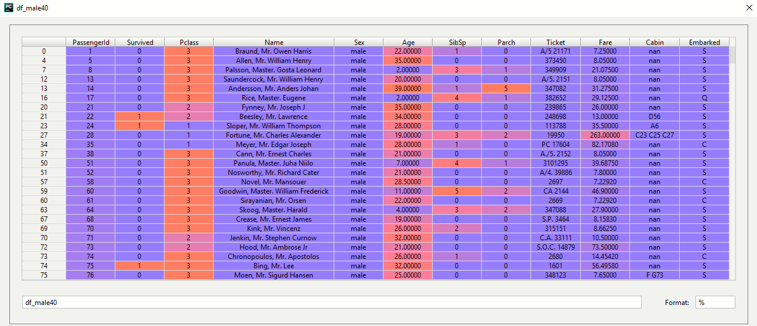**Dataframe holding data for males with age less than 40:**

**RESULT:**

